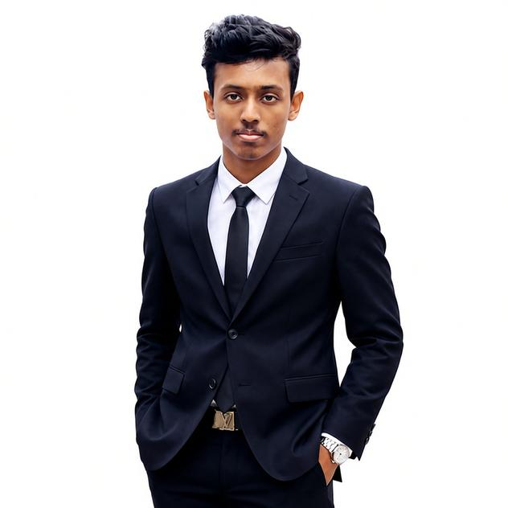 |  | Ayesh chamodya  Software Engineer
Profile  Hello! I'm Ayesh Chamodye, a passionate software developer with a strong interest in building innovative web solutions. My journey in tech began with a fascination for creating digital experiences that solve real-world problems.  With experience in both front-end and back-end technologies, I enjoy working across the full stack. I'm particularly interested in cloud infrastructure, scalable architectures, and crafting intuitive user interfaces.  Contact  PHONE:  +94766568369  WEBSITE:  https://ayesh-dev.lovable.app/  EMAIL:  ayeshchamodye@gmail.com  GITHUB  https://github.com/ayesh-chamodye  LINKED IN:  www.linkedin.com/in/ayesh-chamodye  Refferences  Ms. Iresha Jayarathne  Assistant Program Manager  ESOFT Metro Campus - Kurunegala  lasitha.ranawaka@esoft.lk  Mr. Lasitha Ranawaka  Head of Academic Affairs  ESOFT Metro Campus – Kurunegala  lasitha.ranawaka@esoft.lk |  | EDUCATION  ESOFT Metro Campus Kurunegala – Level 3 Diploma in IT  2024/02/05 – 2024/10/05  Distinction [TOP Performer]  ESOFT Metro Campus Kurunegala – HND in Computing  2024/10/02 – 2026/04/02  Following  Sri Sumangala National college Wariyapola – A/L  2023  B-1 F-2  Sri Gnanodaya Central College Wariyapola – O/L  2020  A-1 B-3 C-5  EXTRA ACTIVITIES  2nd runner up in Thinkfest hackathon  I won 2nd runner up place of Thinkfest Hackathon 2025 hosted by ESOFT island wide against 40+ branches.  Practical tutoring sessions for diplomates  I’m doing some practical tutoring sessions for diplomates in ESOFT Kurunegala during my free time as a service.  SKILLS

